Revivion ANN

Lecture 2a-2b :

Hebb’s learning hypothesis: Simultaneous activation of two neurons strengthens their synaptic inter‐connection. Delta w = xiyj
D'ou
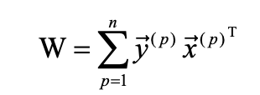
ainsi
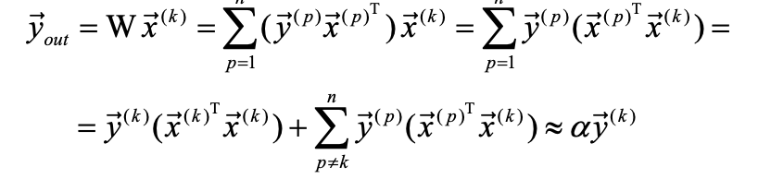
if the patterns x(k) are hortogonals

Perceptron Learning :
if x is well classify do nothing, else if the result is 0 and should be 1, delta w = x else delta w = -x

If a solution exists for a finite training dataset then perceptron learning always converges after a finite number of steps (independent of step size/learning rate)

Delta rule (need symetric tarrget value 1,-1):
Error is measured before thresholding : e =t-wx, find the weights that minimise the error function e^2/2. With the descent gradient. Then we got delta w = nex
delta rule for a perceptron leads to faster convergence than perceptron learning rule in linearly separable problems
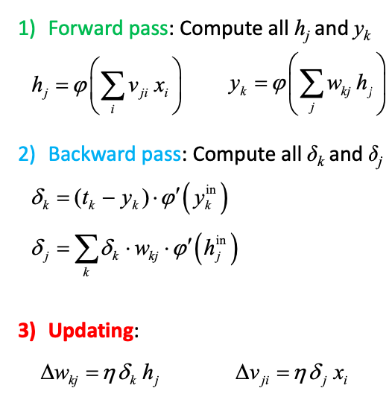
generalised delta rule : Use threshold‐like but differentiable function (for delta)
Pb with backpropagation : slow convergence, getting stuck in local minima, many parameters msut be tuned, challenging scaling
sequential (online) vs batch mode :
− Sequential update is faster (though requires lower learning rate) especially for large data sets with redundancy
− On‐line scheme is less susceptible to getting stuck in local minima (noise)
− However, sequential update does not implement a true gradient descent, it
is referred to as stochastic gradient descent (SGD)
weight initialisation : random initialization, Gaussian distribution N(0,σ) , uniform distribution with zero mean and σ^2 = 1/fan_in (heuristic).
Learning rate adaptation : too low η makes learning very slow, too large η makes the weights overshoot the error minimum, adaptative schemes n(t) = n(1)/t or n(t) = n(1)/(1+t/tau).
Add momentum
faster convergence with anti‐symmetric activation function
maximising information content of data samples
off‐setting target values to minimize the risk of sigmoid saturation
data preprocessing – normalization (e.g. mean removal, decorrelation)
hyperparameter selection

Lecture 3
Key factors that have impact on the generalization
-size and quality (how representative it is for the problem) of training data
-complexity of the learning machine
- the physical complexity of the underlying problem
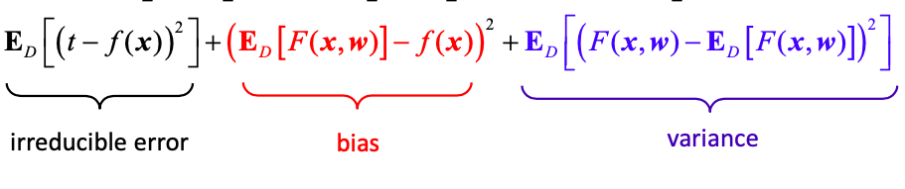
The need to balance bias (approximation error) and variance (estimation error) on a limited data sample
The problem can be alleviated by large data amount,
Balance boils down to selecting optimal network capacity,
Representational vs effective capacity
Underfitting(low variance, high bias) vs overfitting (high variance, low bias)
Estimate based on a hold‐out set to evaluate the generalization capabilities :
To validate the model’s “quality” (generalisation capability)
As a criterion for model selection (comparison)
It can be costly to sacrifice data for validation in problems with low amount of available data for training so there are different ways of resampling data to form a hold‐out set, more robust from a statistical point of view as it allows for estimating confidence intervals (uncertainty).
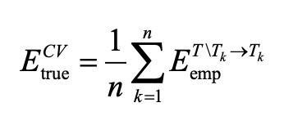
Ex : boostrap (biais estimate), n-fold cross-validation
Adding a noise term (zero mean) to the input training data has been reported to enhance generalisation capabilities of MLPs
In practice, each time the data point is presented for network learning new noise vector should be added
Early stopping (needs a validation set)
Major approaches that avoid exhaustive search and training
- network topology constructed from a set of simpler networks
‐ network committees and mixture of experts : combining the predictions of multiple models can reduce the overfitting, If the errors of individual learners are uncorrelated, Vcom = 1/K*moy(Vind), members of the committee should have relatively low bias at the cost of variance, since the extra variance can be removed, votes/opinions of each learner (e.g. different need for diversity and independence of ANN architectures or ML models) , can also weighted combinaison of individual predictions :
Bagging : train for each different boostrap sample then combine the result
boosting : train weak learners on misclassified data
- network growing or pruning
In growing algorithms, new units or layers are added when some design specifications are not fulfilled (e.g. error increase)
Network pruning starts from a large network architecture and iteratively weakens or eliminates weights based on their saliency
Penalty term regularisation (add a term in the error to control the complexity of the model) promoting smoth solutions, opportunity for incorporating prior knowledge.
L2 regularisation (weight decay) : \sum wi^2
L1 reg (Lasso): \sum abs(wi)
L1 incourage sparsity, when |w| is large L2 shrinks faster than L1, when |w| is small L1 shrinks faster than L2
Adaptive Moment Estimation (Adam) – adaptive moment & learning rate combination of AdaDelta (exponentially decaying average of past squared gradients ) and momentum (exponentially decaying average of past gradients)

